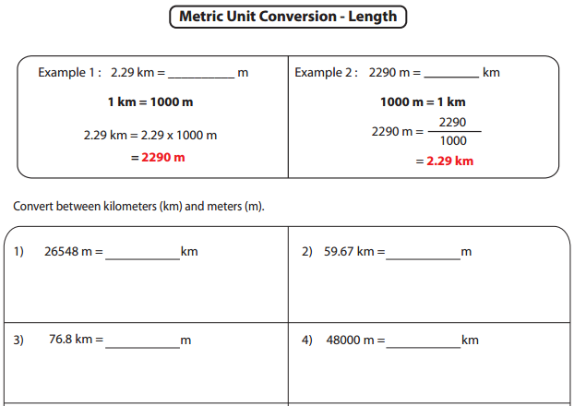

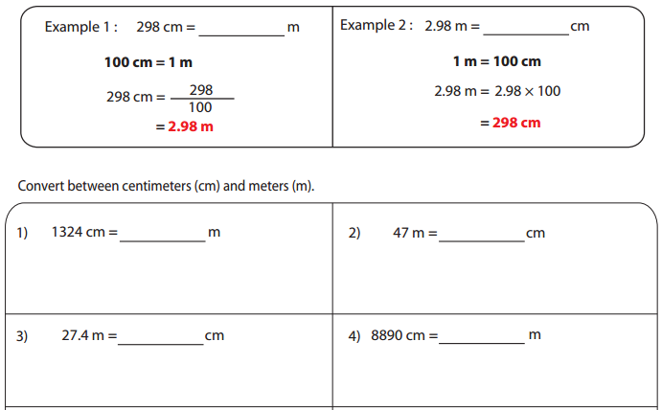

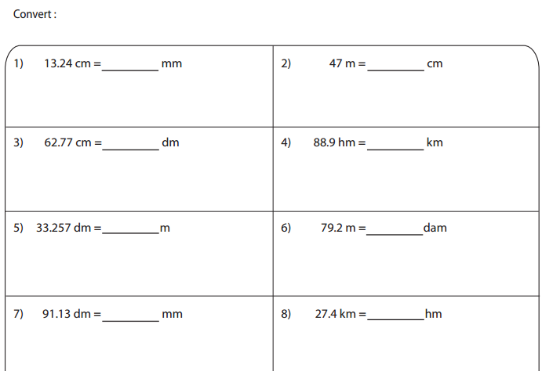

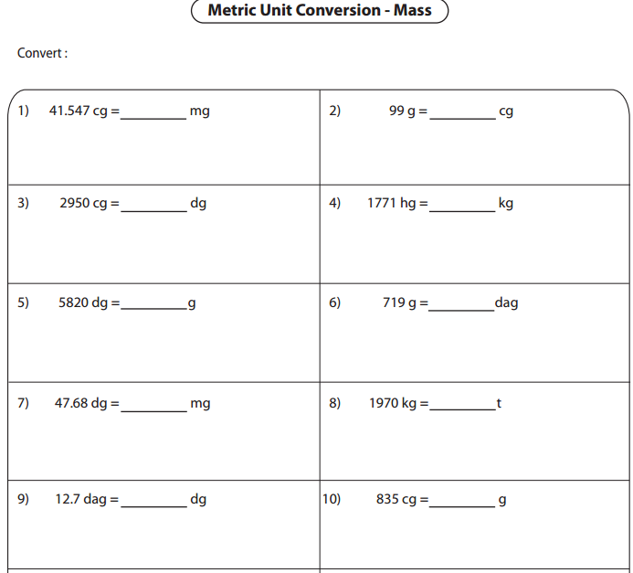

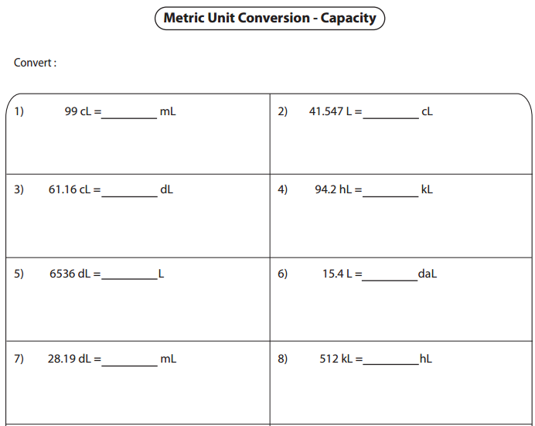
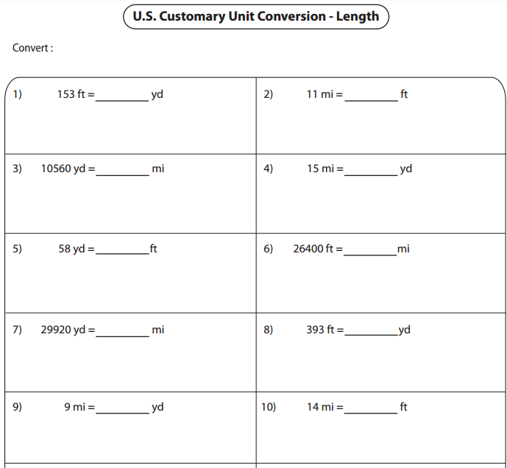

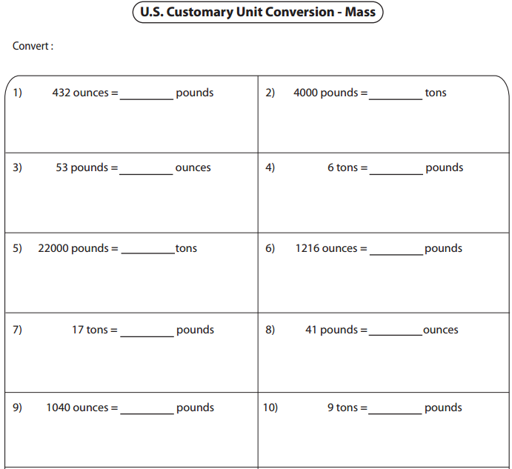
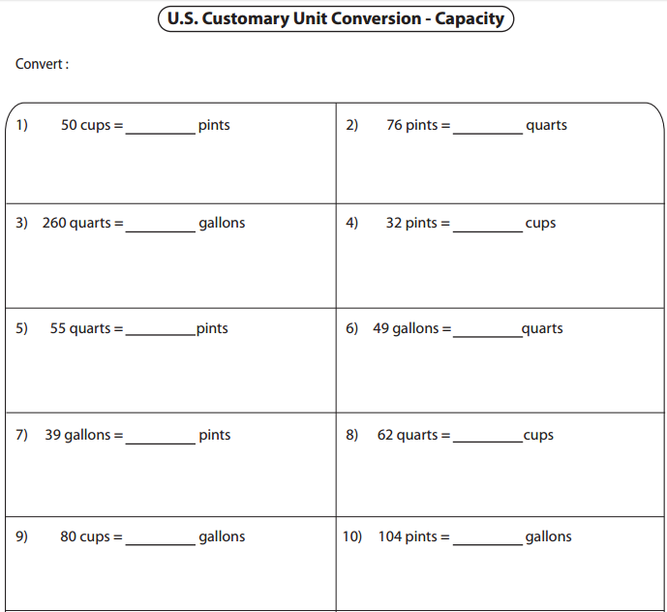

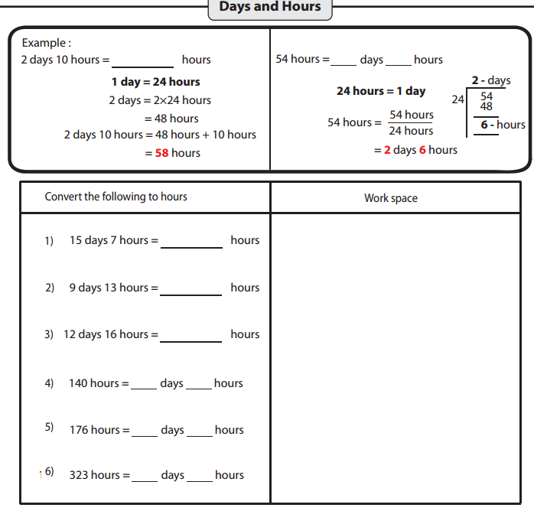

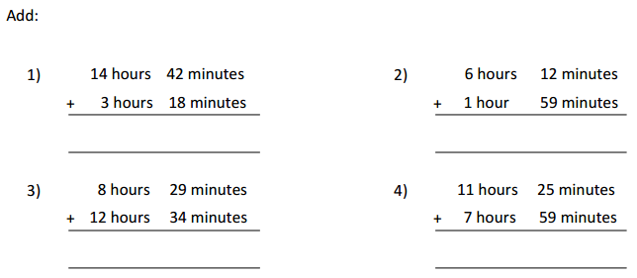

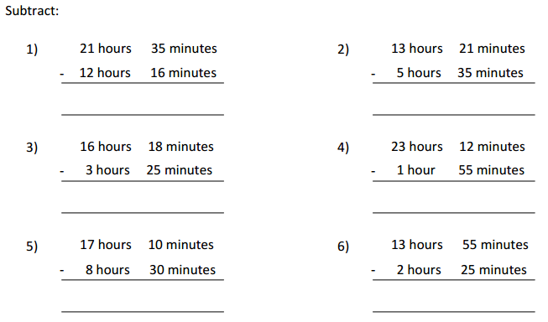

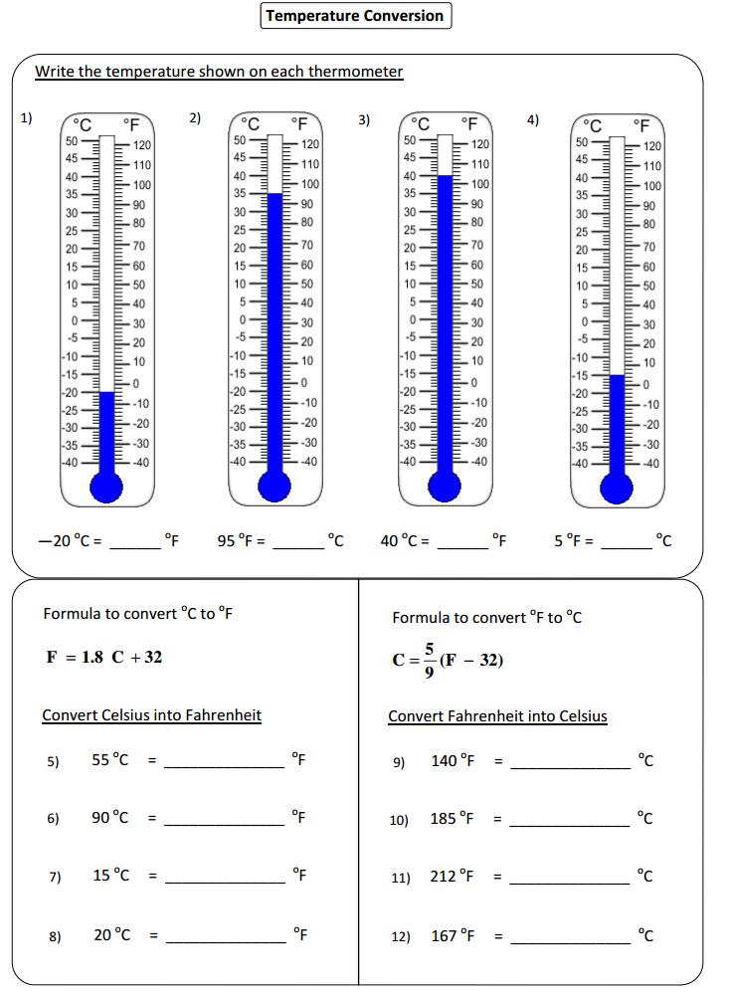

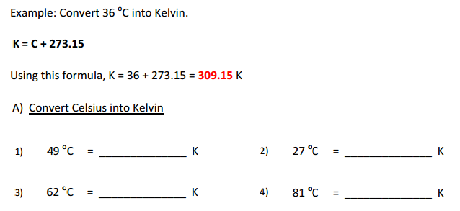

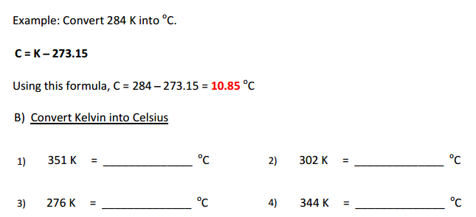

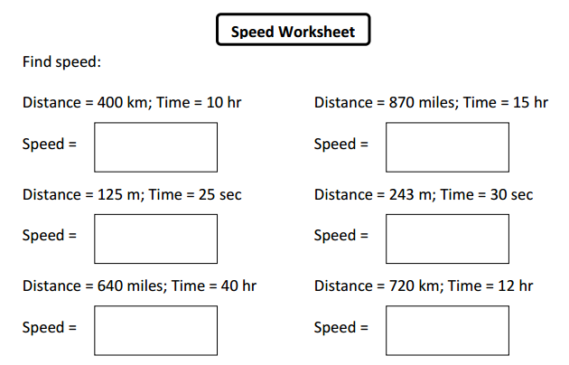

Convert m/s into km/hr
- 70 m/sec =

- 5 m/sec =

- 40 m/sec =

Convert km/hr into m/sec
- 72 km/hr =

- 108 km/hr =

- 18 km/hr =

- If Lisa has 5000mg of salt, how many grams of salt does she have? Show your work.

- If Kyle’s recipe requires 2kg of flour, how much flour does he need in decagrams? Show your work.

- Angela bought 3 varieties of sugar. One of them weighed 2 kg and other two weighed 500 g each? What is the total weight in kilograms of the three varieties of sugar?

- Alexander brought 250-gram flour for $11.50. What is the total cost of 2 kg of flour?

- Mary takes 4 hours to wipe each floor of a building. There are 12 floors. How many minutes does it take her to wipe all the floors?

- Marvin went for a 3 kilometer drive in his car. His brother Kali drives 4000 meters in his car. Kali drove further by how much distance (answer in km)?

- If a gallon of kerosene costs $4.95 and a quart of kerosene costs $1.79, how much is saved by buying the kerosene in gallons instead of quarts, if a person needs 3 gallons of kerosene?

- It was twenty nine degrees before it started raining and temperature dropped by ten degrees. What is the temperature after rain?

- How many kilograms does Mike need to add in a bag weighing two kilograms to make it weigh fourteen kilograms?

- About a month ago, Andrew weighed seventy-six and three tenths kilograms. Now he is eighty-eight and one tenths kilograms. How much weight has he gained?

- A two liter soft drink bottle costs $1.20. What is the cost of the drink per liter?

- If today's temperature is twenty- nine degrees Celsius and that is three degrees hotter than yesterday, then what was yesterday temperature?

